Keithley 4200-SCS Remote Control

# Introduction

In this tutorial, you will learn how to set up remote control and automate measurements for the **Keithley 4200-SCS** using **LPTlib** commands and **SweepMe!** software. The primary goal is to configure a seamless connection between the Keithley 4200-SCS parameter analyzer and a master PC, allowing for automated test sequences and remote control of measurements. By the end of this guide, you will be able to:

1. Establish TCP/IP communication between the Keithley 4200-SCS and a master PC.
2. Install and configure the LPTlib server on the Keithley 4200-SCS.
3. Set up SweepMe! on the master PC to automate measurements and control the Keithley device remotely.
4. Integrate additional instruments (e.g., wafer probers, temperature controllers) into the measurement automation system.

**Prerequisites**

Before proceeding, ensure that you have the following hardware and software ready:

* **Keithley 4200-SCS** with appropriate firmware.
* **Master PC** running Windows OS, connected to the same network or directly via Ethernet.
* **SweepMe! software** installed on the master PC. (If not installed, you can download it from [here](https://sweep-me.net/download_sweepme)).

# Set up lptlib server on Keithley 4200-SCS

## Download and Unpack the LPTlib Application

To enable remote control of the Keithley 4200-SCS, you first need to download the **LPTlib server** application, which will allow the system to receive and process commands from the master PC. Follow the steps below to download and unpack the LPTlib server:

**Step 1: Download the LPTlib Server on the Keithley 4200-SCS**

1. Open your browser and navigate to the **SweepMe! website** at [sweep-me.net](https://sweep-me.net/).
2. Log in to your SweepMe! account using your credentials. If you don't have an account, you will need to create one by clicking on the "Sign Up" option.
3. Once logged in, go to the **Dashboard** by clicking on your username in the top-right corner of the screen.
4. Scroll down to the **Files** section, where you can find a list of available downloads.
5. Download the **4200-SCS LPTlib Server** file.

**Step 2: Unpack the LPTlib Server**

1. After downloading, navigate to the location where the **LPTlib server** file was saved (usually in your Downloads folder).
2. Right-click on the downloaded file, which will be in a compressed format (e.g., a .zip file), and select **Extract All**.
3. Choose a destination folder on the **Keithley 4200-SCS** where you want to extract the files. We recommend placing them in a directory that's easy to access, such as the desktop or a dedicated folder for measurement tools.
4. Once extracted, the folder will contain:
   * A configuration file (4200-server.ini).
   * The server executable file (4200-server.exe).

Make sure you remember the location where you saved these files, as you will need them in the next steps to configure the server and set up the IP address for remote communication.

## Set up IP Address

In this section, we will configure TCP/IP communication to enable a connection between your **Keithley 4200-SCS** and the master PC. Follow these steps to ensure proper setup:

**Step 1. Connect the Devices**

* Use an Ethernet cable to connect the Keithley 4200-SCS directly to your master PC.
* Alternatively, both devices can be connected to the same network if using a network switch or router.

**Step 2. Identify the Network**

* On your Keithley 4200-SCS, open the **Network and Sharing Center** (found in the Control Panel).
* Check which network is associated with your Ethernet connection. It will likely show as **Unidentified Network**. Ein Bild, das Text, Screenshot, Software, Webseite enthält.

  Automatisch generierte Beschreibung

**Step 3. Access Ethernet Properties**

* Click on **Ethernet** to open the network's context menu.
* In the new window, click **Properties**.

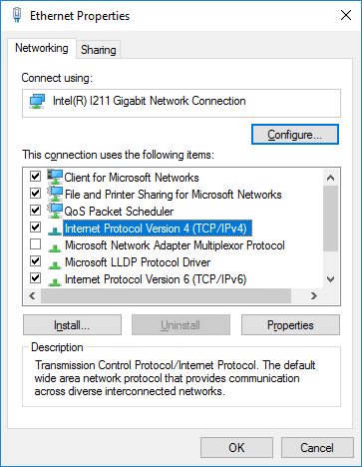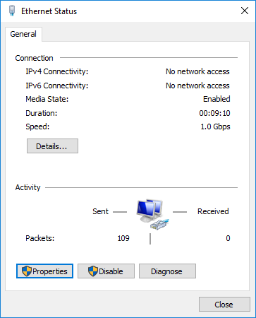

**4. Set a Custom IP Address**

* Select **Internet Protocol Version 4 (TCP/IPv4)** from the list and click **Properties**.
* Configure a static IP address
* **IP Address:** For example, 192.168.0.10
* **Subnet Mask:** Automatically fills to 255.255.255.0
* Click **OK** to save the settings.

Ein Bild, das Text, Elektronik, Screenshot, Display enthält.

**Step 5. Update the 4200 Configuration File**

* Navigate to the folder where you downloaded the Keithley 4200 server files.
* Open the 4200.ini file using a text editor (e.g., Notepad).
* Set the same IP address (192.168.0.10) in the configuration file.
* Save and close the file.

Ein Bild, das Text, Screenshot, Display, Software enthält.

**Step 6 (Optional). Verify the Connection**

* Open **Windows PowerShell** or **Command Prompt** on your Master PC.
* Test the connection by sending a ping to the configured IP address:
* Open the Windows PowerShell and use the command: ping 192.168.0.10

Ein Bild, das Text, Elektronik, Screenshot, Display enthält.

# Allow TCP/IP Communication

To enable communication between the **Keithley 4200-SCS** and your measurement PC, the Windows Firewall settings must be adjusted. Follow the steps below on both devices.

**1. Open the Firewall Settings**

* Open the Start menu and search for **Windows Firewall with Advanced Security**.
* On German PCs it may be listed as **Windows Defender Firewall mit erweiterter Sicherheit**.
* Right-click on the application and select **Run as Administrator**.

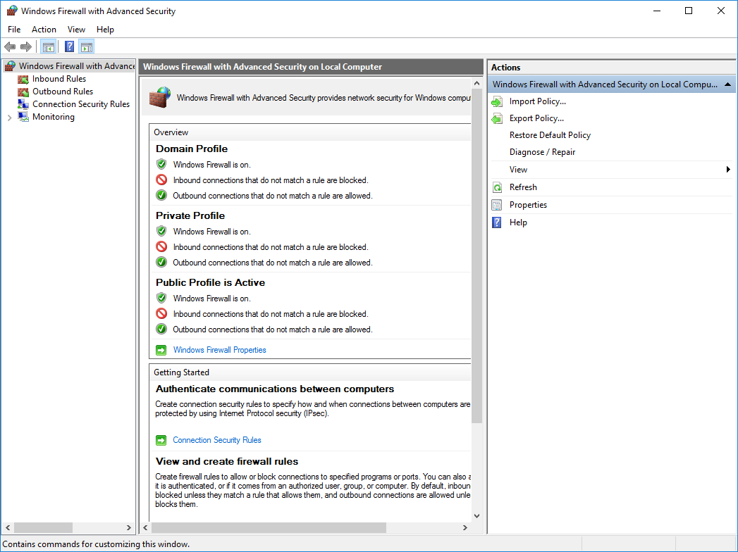

* Click on **Windows Firewall Properties.**

**3. Configure the Public Profile**

* In the **Windows Firewall Properties** window:
  1. Navigate to the **Public Profile** tab.
  2. Locate **Protected network connections** and click **Customize**.
  3. Uncheck the box for the network being used for the communication (e.g., **Ethernet** or **Unidentified Network**).
  4. Click **OK** to save changes.

Ein Bild, das Text, Elektronik, Screenshot, Display enthält.
Ein Bild, das Text, Elektronik, Screenshot, Software enthält.

# Set up SweepMe!

To automate measurements and control the **Keithley 4200-SCS**, you'll use **SweepMe!**. Follow these steps to set up the software and configure your measurement.

**1. Install SweepMe!**

* Download the **SweepMe! installer** from the [official SweepMe! website](https://sweep-me.net/download_sweepme).
* Follow the installation instructions provided on the website.

**2. Start SweepMe! and Add Modules**

* Launch **SweepMe!** after installation.
* To add the required driver and modules:
  1. Go to **Tools** > **Modules & Devices**.
  2. In the search bar, type **SMU**.
  3. Activate the **SMU Module**.

Ein Bild, das Text, Screenshot, Software, Zahl enthält.

**3. Add the Keithley 4200-SCS Driver**

* In the same **Modules & Devices** menu, search for **Keithley 4200-SCS**.
* Activate the corresponding driver.

Ein Bild, das Text, Screenshot, Software, Zahl enthält.

**4. Create a New Setting**

* Create a new measurement setting by adding the following modules:
  + **MakeFile Module**: To structure and save your measurement sequence.
  + **SMU Module**: To control the Keithley 4200-SCS.

Ein Bild, das Text, Screenshot, Software, Display enthält.

**5. Configure the SMU Module**

* Open the **SMU1** tab in your setting to configure your measurement device:
  1. **Device**: Select **SMU-Keithley_4200-SCS**.
  2. **Channel**: Choose the specific SMU channel from your Keithley 4200-SCS hardware.
  3. **Port**: Click **Find Ports**, then:
     + Add the **IP Address** of the Keithley 4200-SCS set up earlier.
  4. **Sweep Mode**: Choose a sweep mode. For example:
     + **Voltage**: To perform a voltage sweep.
     + **Sweep value**: Set this to **SweepEditor**.
  5. Configure other measurement parameters as needed for your experiment. Ein Bild, das Text, Screenshot, Zahl, Software enthält.

     Automatisch generierte Beschreibung

**6. Set Up Sweep Values**

* Navigate to the **Sweep Values** tab:
  1. Use the **SweepEditor** to define the range and step size for the sweep (e.g., start voltage, stop voltage, and increment).

Ein Bild, das Screenshot, Text, Software, Computersymbol enthält.

# **7. (Optional) Add a Plot Widget**

To visualize the measurement data in real-time:

1. Go to **Widgets** > **Plot**.
2. Drag the plot widget into the dashboard.
3. Double-click the plot to configure the axis labels and scaling as required.

# Start the measurement

**Start the Measurement**

Now that everything is configured, you're ready to begin your automated measurement. Follow these steps:

**1. Start the 4200 Server**

* On the **Keithley 4200-SCS**:
  1. Locate and run the 4200-server.exe file.
  2. Ein Bild, das Text, Screenshot, Display, Software enthält.

     Automatisch generierte BeschreibungEnsure that the server is running; it must stay active for remote control to function.

**2. Run the Measurement in SweepMe!**

* On the **Master PC**:
  1. Click the **Run** button at the top of the SweepMe! interface.
  2. The measurement will begin, and data will start populating your configured plot widget in real-time.

**3. Monitor and Analyze Data**

* Use the plot window to monitor the progress of your measurement.
* If adjustments are needed, stop the measurement, modify parameters, and restart in SweepMe!.

# Next Steps

**1. Learn More About SweepMe!**

* Explore the comprehensive **Getting Started** guide to deepen your understanding of SweepMe!'s features and how to integrate additional instruments into your test routines:  
  [Getting Started with SweepMe!](https://wiki.sweep-me.net/wiki/Getting_Started)

**2. Create Complex Test Routines**

* Design advanced workflows by combining logical modules, conditional logic, and multiple devices. Learn more about these features at:  
  [SweepMe! Modules](https://sweep-me.net/modules)

**3. Get Help and Support**

* For troubleshooting or to discuss ideas with other users, visit the **SweepMe! Forum**:  
  [SweepMe! Forum](https://forum.sweep-me.net/)
* If you need direct assistance, feel free to contact the **SweepMe! Support Team**:  
  [Contact SweepMe!](https://sweep-me.net/contact)